Intsusa Films brief.

Example https://slingshotmedia.co.za/home/photography/a-right-to-choose/

About us

Founded in 2020 intsusa films is an award winning documentary film and photography company based in Cape Town, South Africa .

(Here you branch to the image of me and then have this writing under or opposite me. )

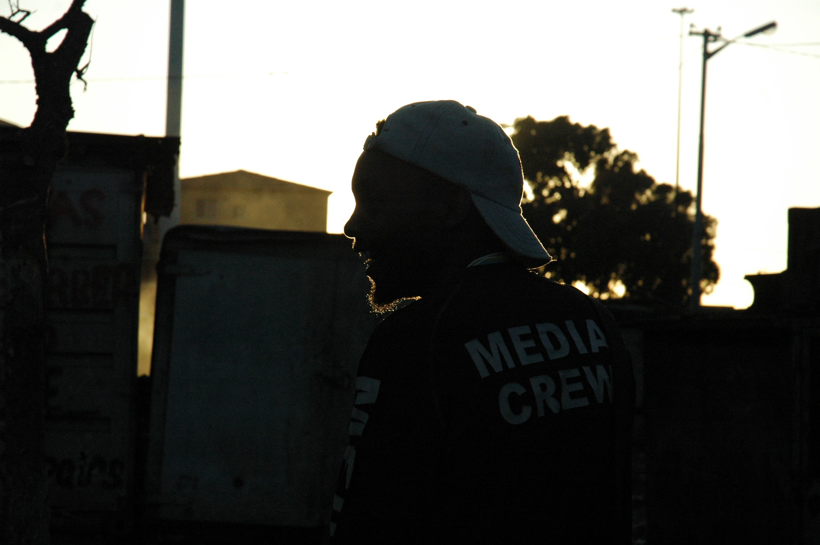

My involvement in community development has given me an incredible experience in inclusive, digital storytelling.

Using the power of media as a tool to resist and change our social and environmental challenges that continue to arise daily in our communities and our beautiful nature.

My primary focus is documentary filmmaking where my core competencies are research, videography, directing, and editing ideally while training young people in basic storytelling.

(Here I want to portray my portfolio)

Create a FiLM PAGE then on the page, the films must be displayed then with a title underneath, for the next to play, make it the behaviour of the page in such a way that they scroll left for the next film like the one under.

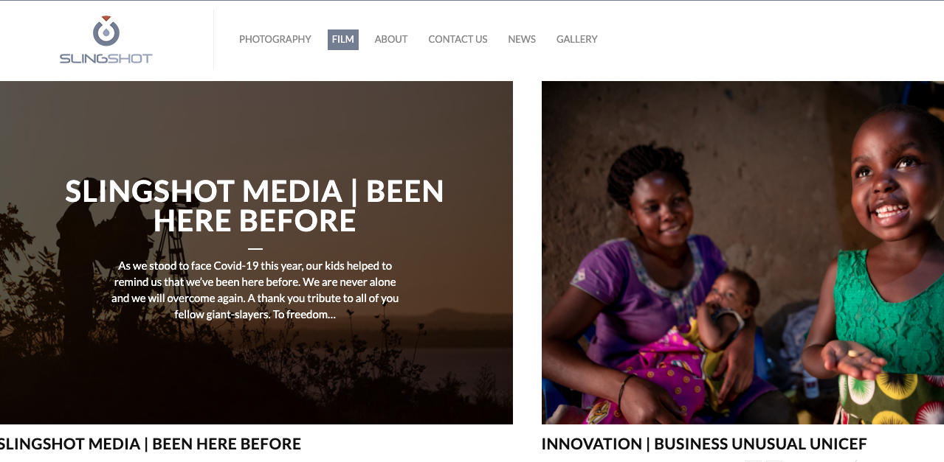

This one is for photographs that I will keep adding with time. Having one or two will be okay, I am not sure what they gonna be yet but I will share them when you need them.

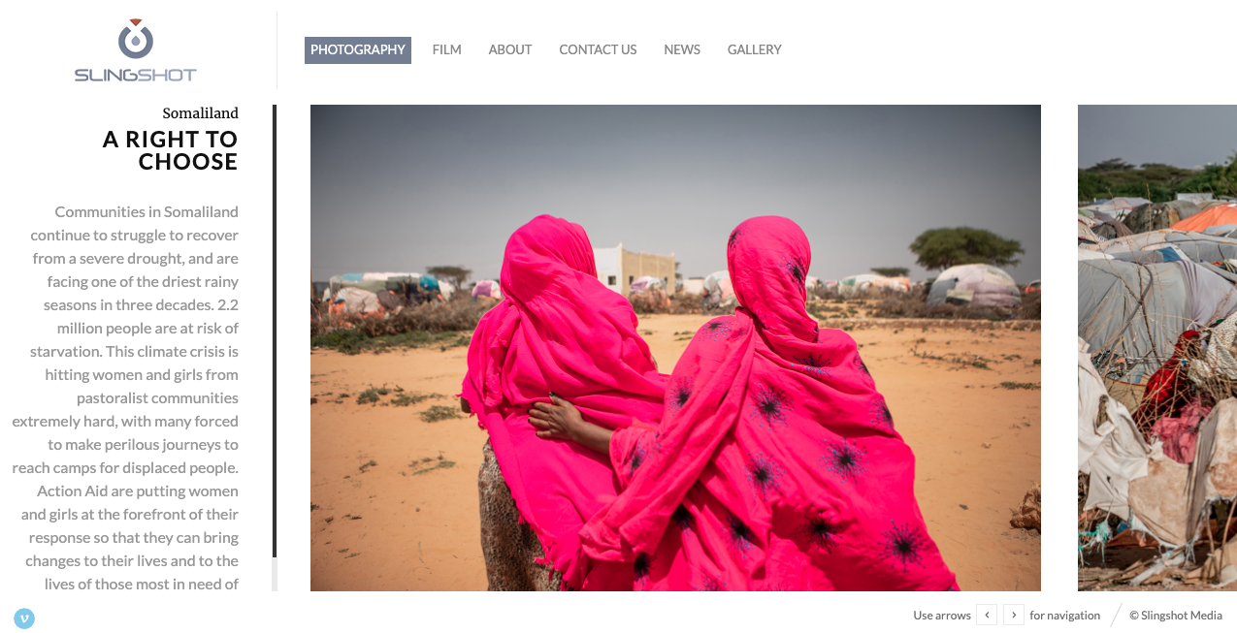

Reference site.

Quote Words.

